# **Name: Abdurrahman Qureshi**

# **Roll No: 210451**

Practical No: 12

**1) Write a Program to show the following output. First two radio buttons are without using radio group and next two radio buttons are using radio group. Note changes between these two. Also Toast which radio button has been selected.**

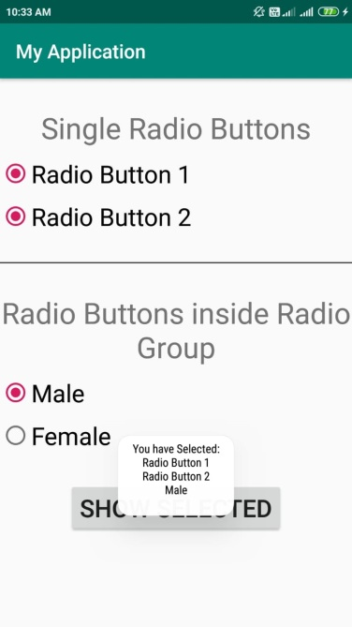

**XML CODE:**

<?xml version="1.0" encoding="utf-8"?>  
<LinearLayout xmlns:android="http://schemas.android.com/apk/res/android"  
 xmlns:app="http://schemas.android.com/apk/res-auto"  
 xmlns:tools="http://schemas.android.com/tools"  
 android:layout_width="match_parent"  
 android:layout_height="match_parent"  
 tools:context=".MainActivity"  
 android:gravity="center"  
 android:padding="10dp"  
 android:orientation="vertical">  
  
 <TextView  
 android:layout_width="wrap_content"  
 android:layout_height="wrap_content"  
 android:text="Single Radio Buttons"  
 android:layout_marginBottom="10dp"  
 android:textSize="40sp"/>  
  
 <RadioButton  
 android:id="@+id/radioBtn1"  
 android:layout_width="wrap_content"  
 android:layout_height="wrap_content"  
 android:text="Radio Button 1"  
 android:layout_gravity="left"  
 android:textSize="24sp"/>  
  
 <RadioButton  
 android:id="@+id/radioBtn2"  
 android:layout_width="wrap_content"  
 android:layout_height="wrap_content"  
 android:text="Radio Button 2"  
 android:layout_gravity="left"  
 android:textSize="24sp"/>  
  
 <View  
 android:layout_width="match_parent"  
 android:layout_height="6dp"  
 android:layout_marginVertical="25dp"  
 android:background="#737373"/>  
  
 <TextView  
 android:layout_width="wrap_content"  
 android:layout_height="wrap_content"  
 android:text="Radio Buttons Inside Radio Group"  
 android:gravity="center"  
 android:layout_marginBottom="10dp"  
 android:textSize="40sp"/>  
  
 <RadioGroup  
 android:id="@+id/radioGroup1"  
 android:layout_width="wrap_content"  
 android:layout_height="wrap_content"  
 android:layout_gravity="left">  
  
 <RadioButton  
 android:id="@+id/rBMale"  
 android:layout_width="wrap_content"  
 android:layout_height="wrap_content"  
 android:text="Male"  
 android:checked="true"  
 android:textSize="24sp"/>  
  
 <RadioButton  
 android:id="@+id/rBFemale"  
 android:layout_width="wrap_content"  
 android:layout_height="wrap_content"  
 android:text="Female"  
 android:textSize="24sp"/>  
  
 </RadioGroup>  
   
 <Button  
 android:id="@+id/showBtn"  
 android:layout_width="wrap_content"  
 android:layout_height="wrap_content"  
 android:text="Show Selected"  
 android:textSize="25sp"  
 android:layout_marginTop="20dp"/>  
  
</LinearLayout>

**JAVA CODE:**

package com.example.madprac12;  
  
import androidx.appcompat.app.AppCompatActivity;  
  
import android.os.Bundle;  
import android.view.View;  
import android.widget.Button;  
import android.widget.RadioButton;  
import android.widget.RadioGroup;  
import android.widget.Toast;  
  
public class MainActivity extends AppCompatActivity {  
  
 @Override  
 protected void onCreate(Bundle savedInstanceState) {  
 super.onCreate(savedInstanceState);  
 setContentView(R.layout.*activity_main*);  
  
 RadioButton radioButton1 = (RadioButton) findViewById(R.id.*radioBtn1*);  
 RadioButton radioButton2 = (RadioButton) findViewById(R.id.*radioBtn2*);  
 RadioGroup radioGroup = (RadioGroup) findViewById(R.id.*radioGroup1*);  
 Button showButton = (Button) findViewById(R.id.*showBtn*);  
  
 showButton.setOnClickListener(new View.OnClickListener() {  
 @Override  
 public void onClick(View view) {  
 StringBuilder result = new StringBuilder("Selected options:\n");  
  
 if(radioButton1.isChecked())  
 result.append(radioButton1.getText().toString() + "\n");  
 if(radioButton2.isChecked())  
 result.append(radioButton2.getText().toString() + "\n");  
  
 int selectedId = radioGroup.getCheckedRadioButtonId();  
 RadioButton selectedRadioButton = (RadioButton) findViewById(selectedId);  
 result.append(selectedRadioButton.getText().toString());  
  
 Toast.*makeText*(getApplicationContext(), result, Toast.*LENGTH_LONG*).show();  
 }  
 });  
 }  
}

**OUTPUT:**

